Access Reports currently run in order of usage
All Under Dottie2003
Optional Life – the smaller section below is the continuation of the rest of the bottom part of the report, it wouldn’t all fit on the screen.
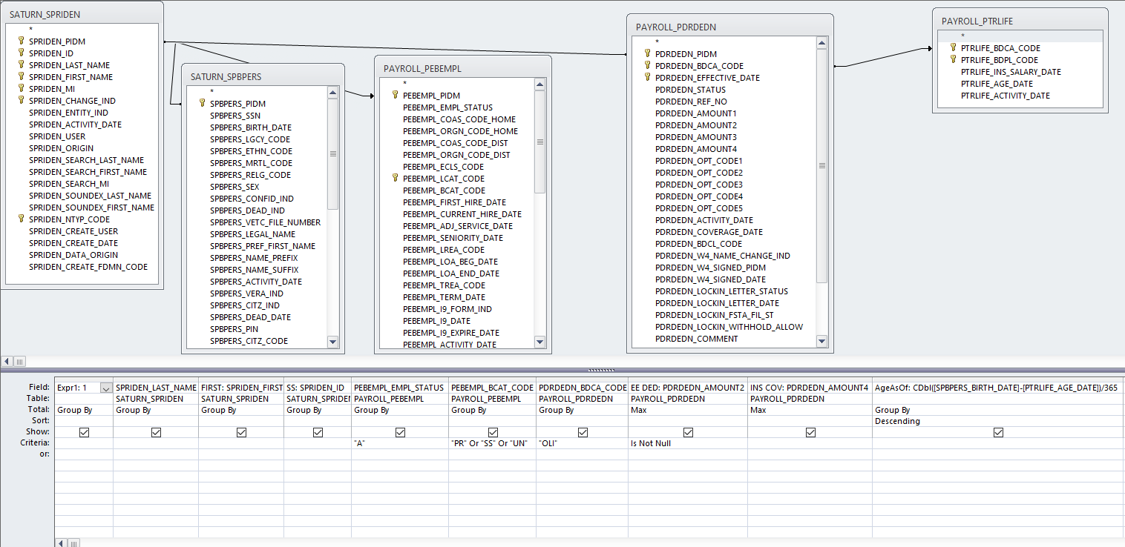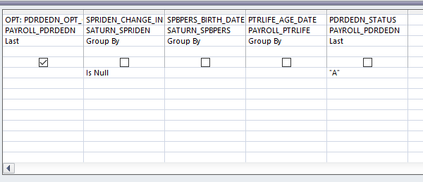
10 over 10 ded – The SPRIDEN_ID will be a spot where I would need to enter a particular C# in order to get their particular deductions. This might be good as an additional option in the above report instead of having two separate reports.
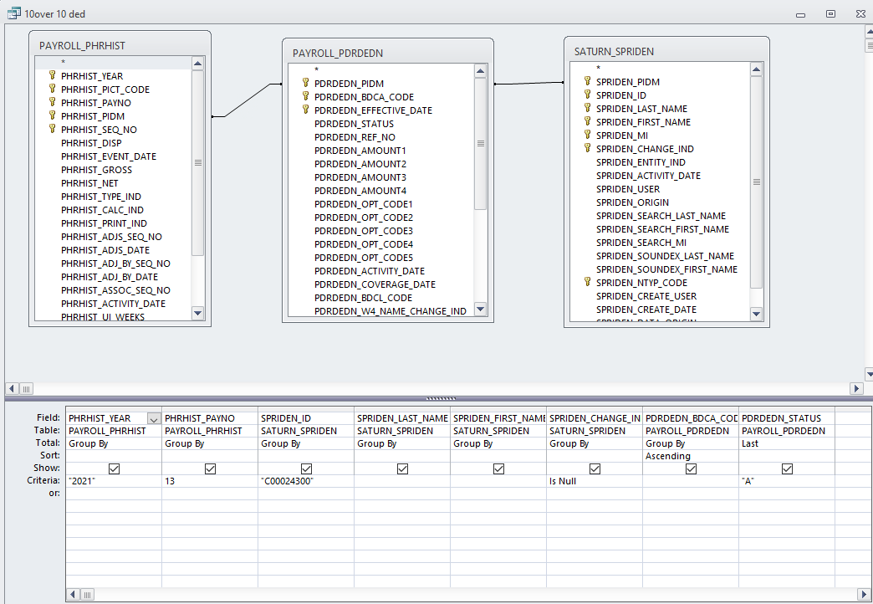
403 Limit – If new BENEFIT_DEDUCT_CODE_KEY are added, I’d need to be able to pick them up as well.
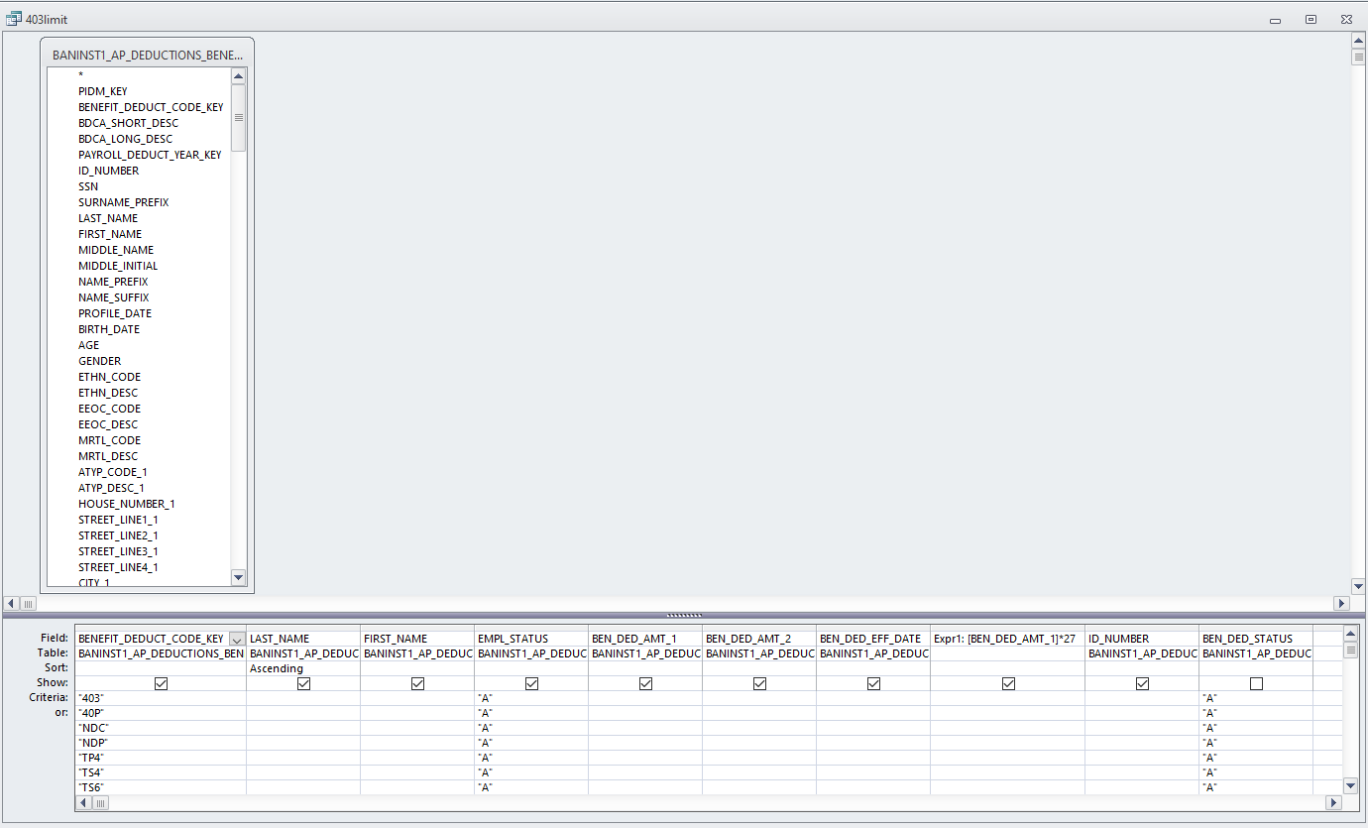

Active Employees with Jobs - see note below
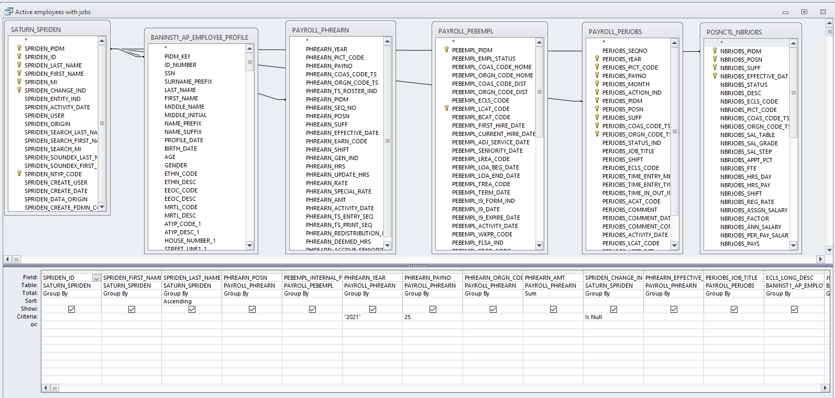
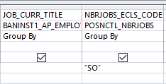 This is the end of choices – the only time the report seems to work is if you choose the ECLS CODE but I’d like to run it open ended with ALL ECLS codes.
Leave by Payroll
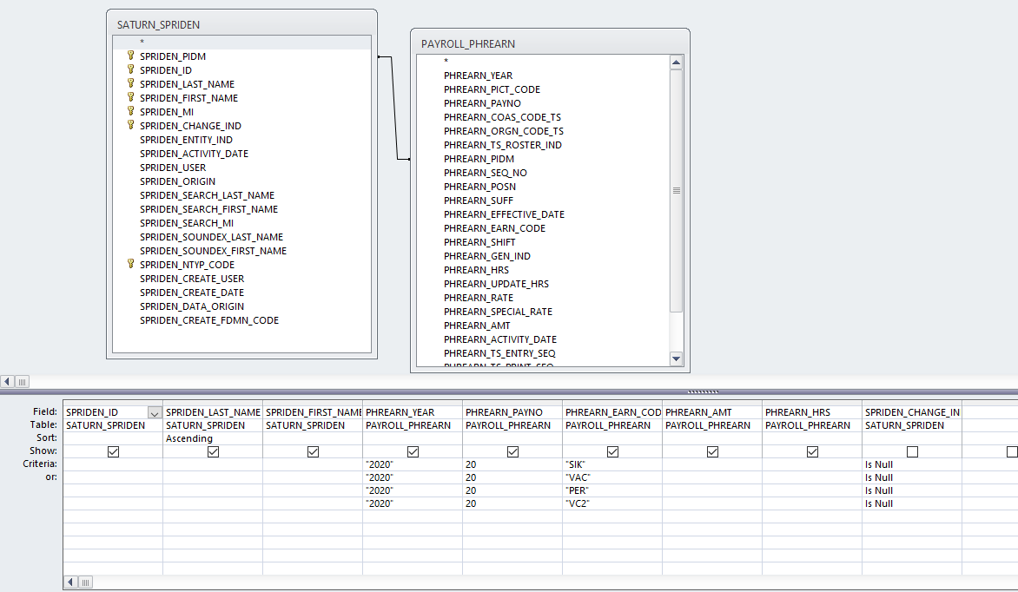

Leave Taken by Day
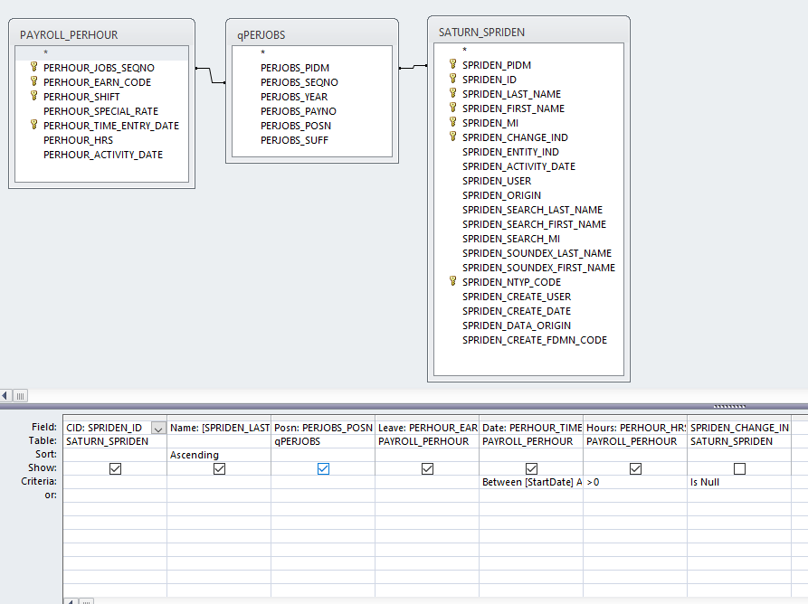
Leave UN Comp
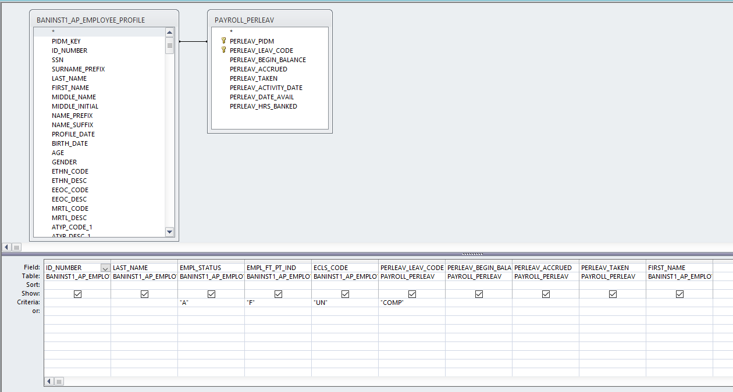

Leave - This one runs personal but I’d like to be able to run any leave type
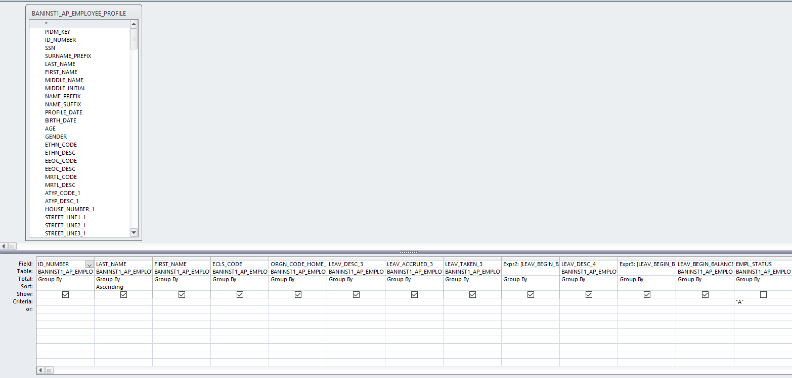
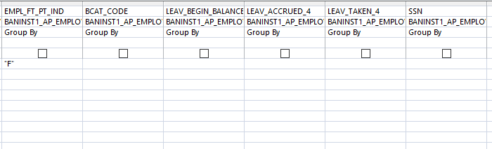
Overtime - this OT report is different than the one Matt created for Kelly in Argos – ideally a dropdown of earn code choices (or multiple choices) would be ideal
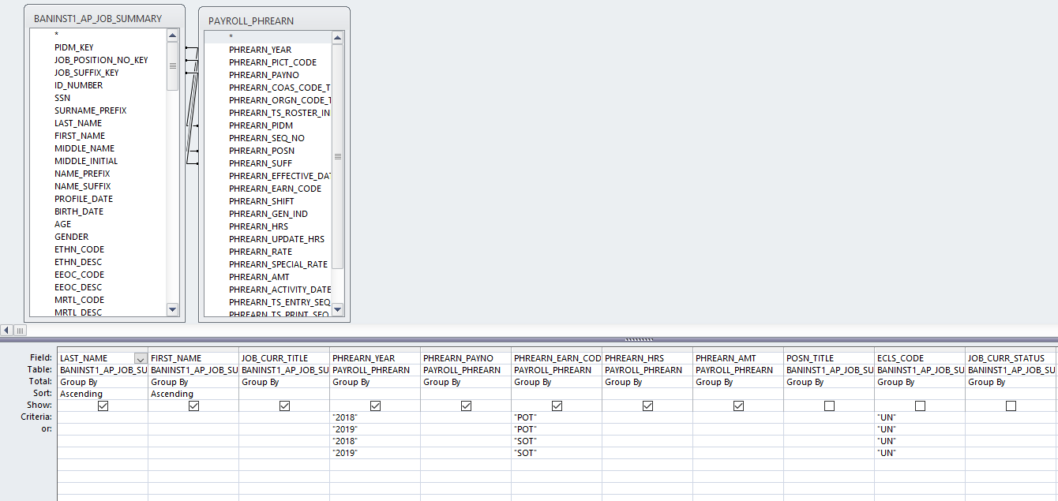

Pay by Earnings
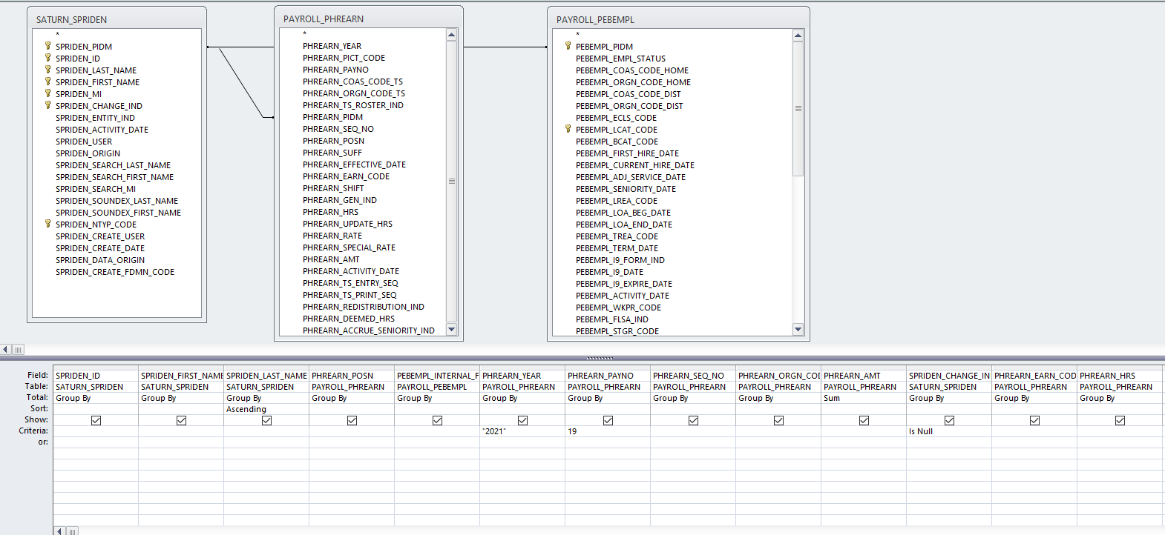

Workers Comp Audit – I update the Queries first that are titled the same as the reports, I need the final output to show the titles for the period of time I’m running (the period of time I run for is February 1 of previous year through January 31 of current year).

- Run reports in Access – Dottie Database
  - WC queries – update years for all WC/OT
  - WC reports – Design view to update dates @ top of page then run report for numbers
    - Workers Comp Audit All January Only
    - Workers Comp Audit All Total Wages
    - Workers Comp Audit All OT
    - Workers Comp Audit Union Total Wages
    - Workers Comp Audit Union OT
    - Workers Comp Audit Security Total Wages
    - Workers Comp Audit Security OT

So the problem with the above reports is that last year someone new took over the Workers Comp Audit and it was VERY challenging last year to get the info they wanted. I think I’ll need these reports but I’ll need them differently. When you get to these reports, can we talk about them?

